Purpose: To see what information about an owl’s diet and niche can be learned from examining an owl pellet.
Background: Refer to the color pages on your lab station prior to beginning the lab. You must use the information on the pages to answer the conclusion questions.
Hypothesis:

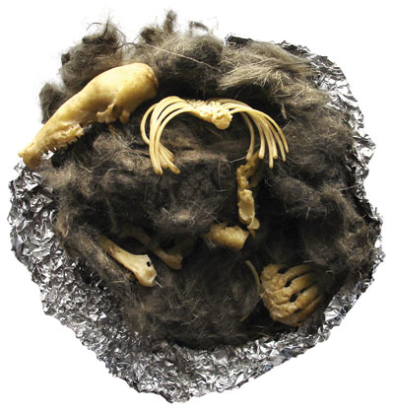
Materials:
- Owl pellet
- Dixie cup
- Tweezers
- Toothpick
- Paper
- Blue plate
- Ruler
- Digital scale
- Magnifying lens

Pre-Lab Questions:
- What are owl pellets?

- How are owl pellets formed?

3. Do only owls produce pellets?

4. What important information can be obtained from owl pellets?

Procedure:
- Work in pairs or teams as your instructor advises.
- Measure the length and width of the pellet with a ruler using the metric side and record it in your data section of your lab write up.
- Place the pellet on the pan of a triple beam balance or digital balance and find its mass. [Make sure that the correct units are used]
- Carefully unwrap the owl pellet. You may see bones or teeth of small animals stuck in the wadded material, but there may be other surprises too! Be patient to see what they are until you perform the next steps.
- Next soak the pellet in water until it is soft.
- Slowly and carefully remove the bones using tweezers or other tool. Be especially careful when you remove skulls and jaws since they can help you identify the animal. Set the bones to dry on the paper plate. Finally carefully roll the last bits of fur between your fingers to feel for any remaining tiny bones or teeth.
- Use the magnifying lens to study and identify the bones. Group bones of the same shape and kind together. Use your dichotomous key to help you identify what type of animal your owl ate. To make sure you are correct you can refer to the chart to the bone charts to help you identify what type of animal (s) you found in the pellet.
- Finally see if you can assemble the bones into a skeleton. Look closely: there may be more than one!
- Most pellets contain a Vole (Microtus), however whatever organism you have glue their skeleton onto a paper. Remember you will need to identify the type of bones before.
Note: Your owl pellet is sterile, but when you are finished with wash your hands anyway!

Data: Length of owl pellet: _____________cm
Width of owl pellet: _______________cm
Mass of owl pellet: ________________g

- Number of bones found in owl pellet:
Rodent | Shrew | Mole | Bird
- Class number of Mole found:
- Class number of Shrew found:
- Class number of Birds found:
- Class number of Rodent found:
- Total number of prey items found:
- Average number of prey items per pellet:
- List the prey found in owl pellet:

Conclusion: Answer the following questions in complete sentences.
- What kind of prey seems to be most abundant?

- Least abundant?

- Draw one food chain that pertains to the feeding pattern of a Barn Owl. Refer to the food web on the colored pages. You must include only the organisms found in your pellet! Label the producer, primary consumer, secondary consumer, tertiary consumer.

